Mahri Kadyrova

BE 3320

Dr Xinlong Wang

Matlab self-project

Independent Component Analysis: according to Arnaud Delorme, ICA technique is used to separate independent data in EEG that has been linearly mixed. Artifacts, which are independent of each other, can be spotted and separated by ICA (3-6). ICA is one way to get rid of artifacts like eye blinks, heartbeat, muscle artifacts etc. Rejected ICA components below are either eye blinks, heart beats or muscle artifacts.

Cleanline at 60 Hz: according to Neuroimaging Tools and Resources Collaboratory CleanLine is EEGLAB specific function that estimates and removes sinusoidal artifacts from Independent Component Analysis (ICA) without creating band holes or distorting significant frequencies around notch frequency. Sinusoidal artifacts are sinusoidal noises that are recorded in EEG and they can be noise from medical equipment, noise from fluorescent lights.Every signal that is electrical will have this high peak noise that needs to be removed (7-8). Cleanline filter out frequency at 60 Hz only and let’s frequencies higher than and lower than 60 be kept for ICA processing with bandpass of 0.5-70.

According to Barry, Clarke, Johnstone, etal, skin conductance levels increased from eyes-closed to eyes-open conditions and it is important to have difference score of open and closed eyes to acquire topography of waves (1). Another article stated that they performed a difference score of EEG power in the eyes closed from eyes open condition for bands that were showing significant Condition effects and those bands were all bands (2). According to Barry BBarry, Clarke, Johnstone etal “topographical differences in the non-alpha EEG bands are compatible with increases in processing related activation from the eyes-closed to the eyes-open condition” and it is possible that by subtracting power values of EEG of open and closed eyes, more artifacts are eliminated which give us better quality brainmaps (1).

Articles and links used:

1. Robert J. Barry, Adam R. Clarke, Stuart J. Johnstone, Christopher R. Brown,EEG differences in children between eyes-closed and eyes-open resting conditions,Clinical Neurophysiology,Volume 120, Issue 10,2009,Pages 1806-1811,ISSN 1388-2457,https://doi.org/10.1016/j.clinph.2009.08.006. (<https://www.sciencedirect.com/science/article/pii/S1388245709004891>)
2. <https://dspace.nal.gov.au/xmlui/bitstream/handle/123456789/1084/Development%20of%20frontal%20EEG%20differences%20between%20eyes-closed%20and%20eyes-open%20resting%20conditions%20in%20children%20data%20from%20a%20single-channel%20dry-sensor%20portable%20device.pdf?sequence=1&isAllowed=y>
3. <http://arnauddelorme.com/ica_for_dummies/>
4. <https://sccn.ucsd.edu/wiki/Chapter_09:_Decomposing_Data_Using_ICA>
5. <https://ieeexplore.ieee.org/document/1504590>
6. https://cnl.salk.edu/~jung/artifact.html
7. <https://www.nitrc.org/projects/cleanline>
8. <https://bigdatawg.nist.gov/HackathonTutorial.html>

Data analysis :

After cleanline of closed eyes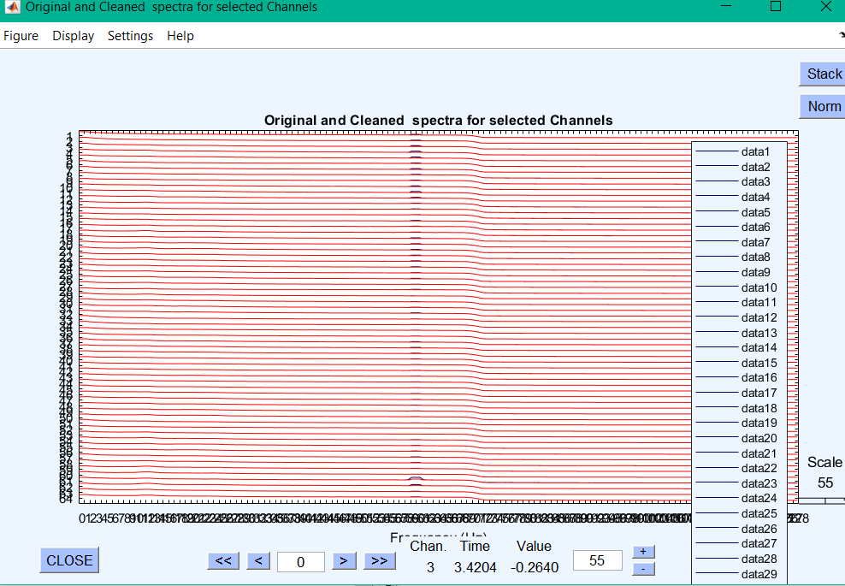

After cleanline of open eyes file 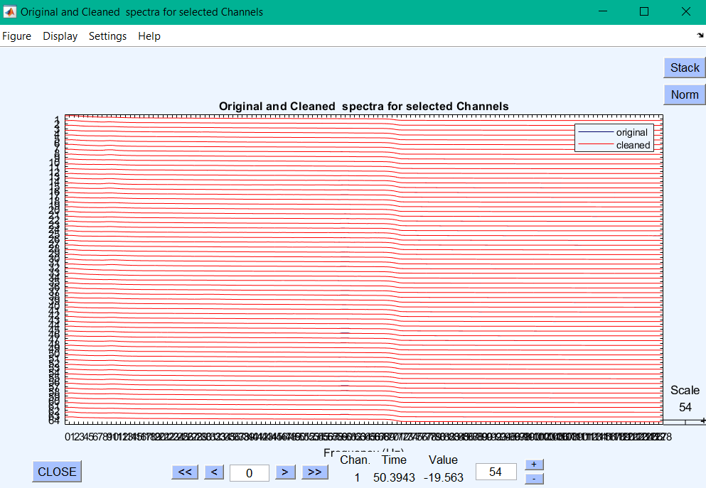

Rejecting components by map of closed eyes

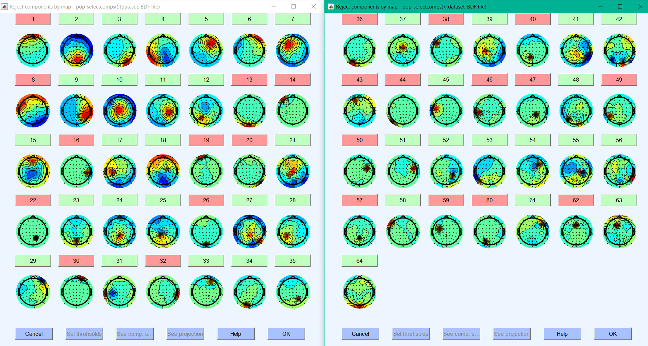

Rejecting components by map in open eyes file

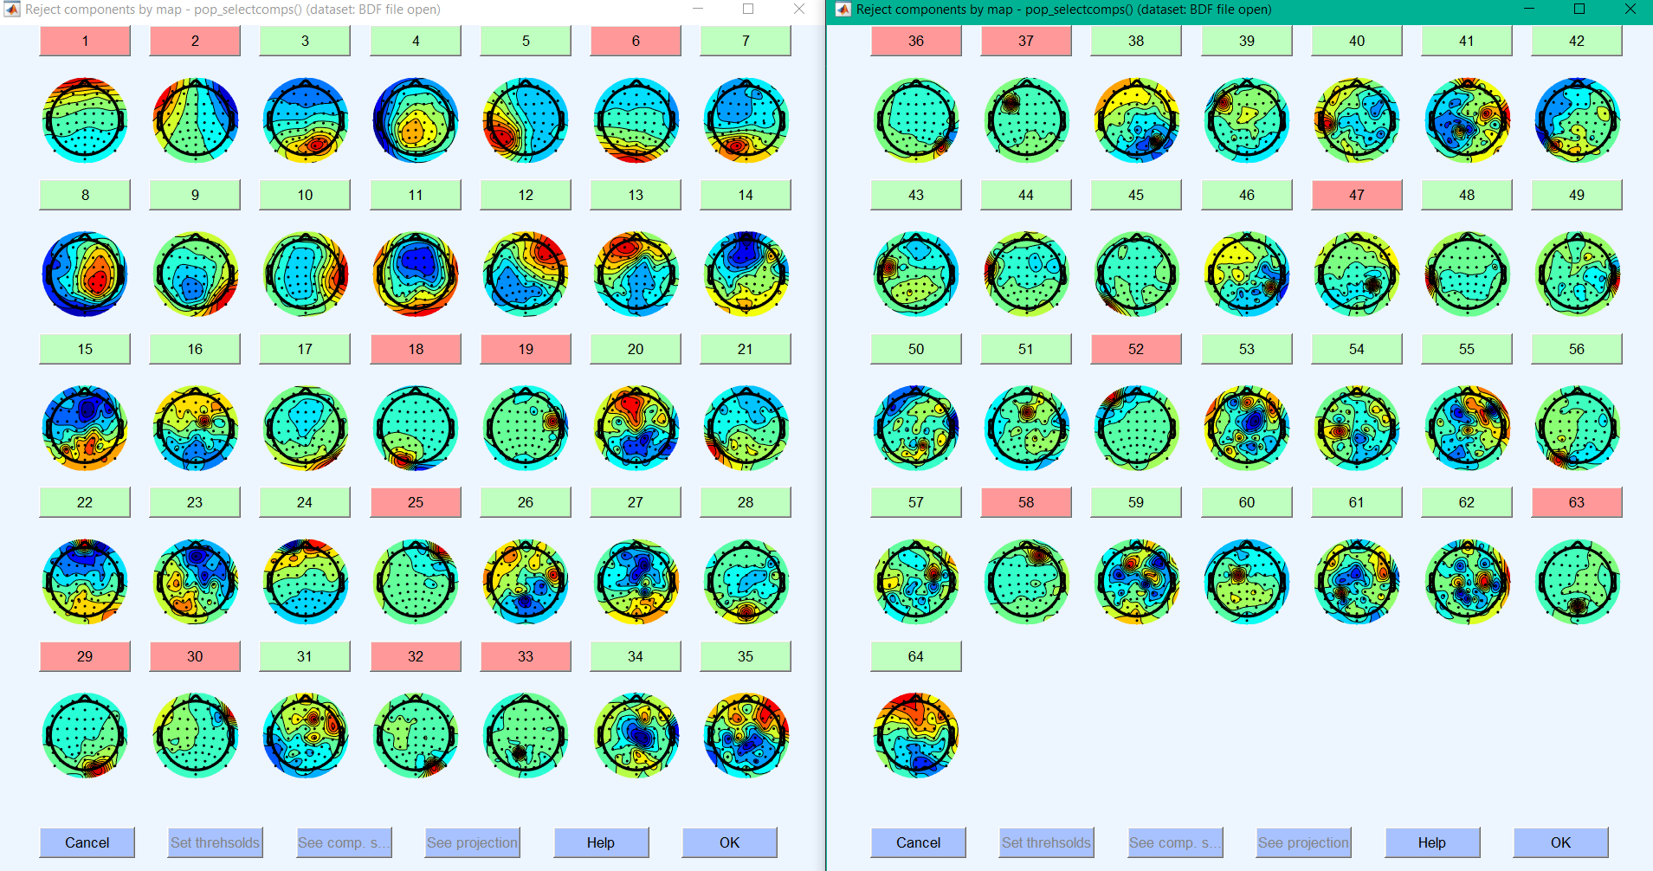

The before (left) and after (right) ICA removal – closed eyes

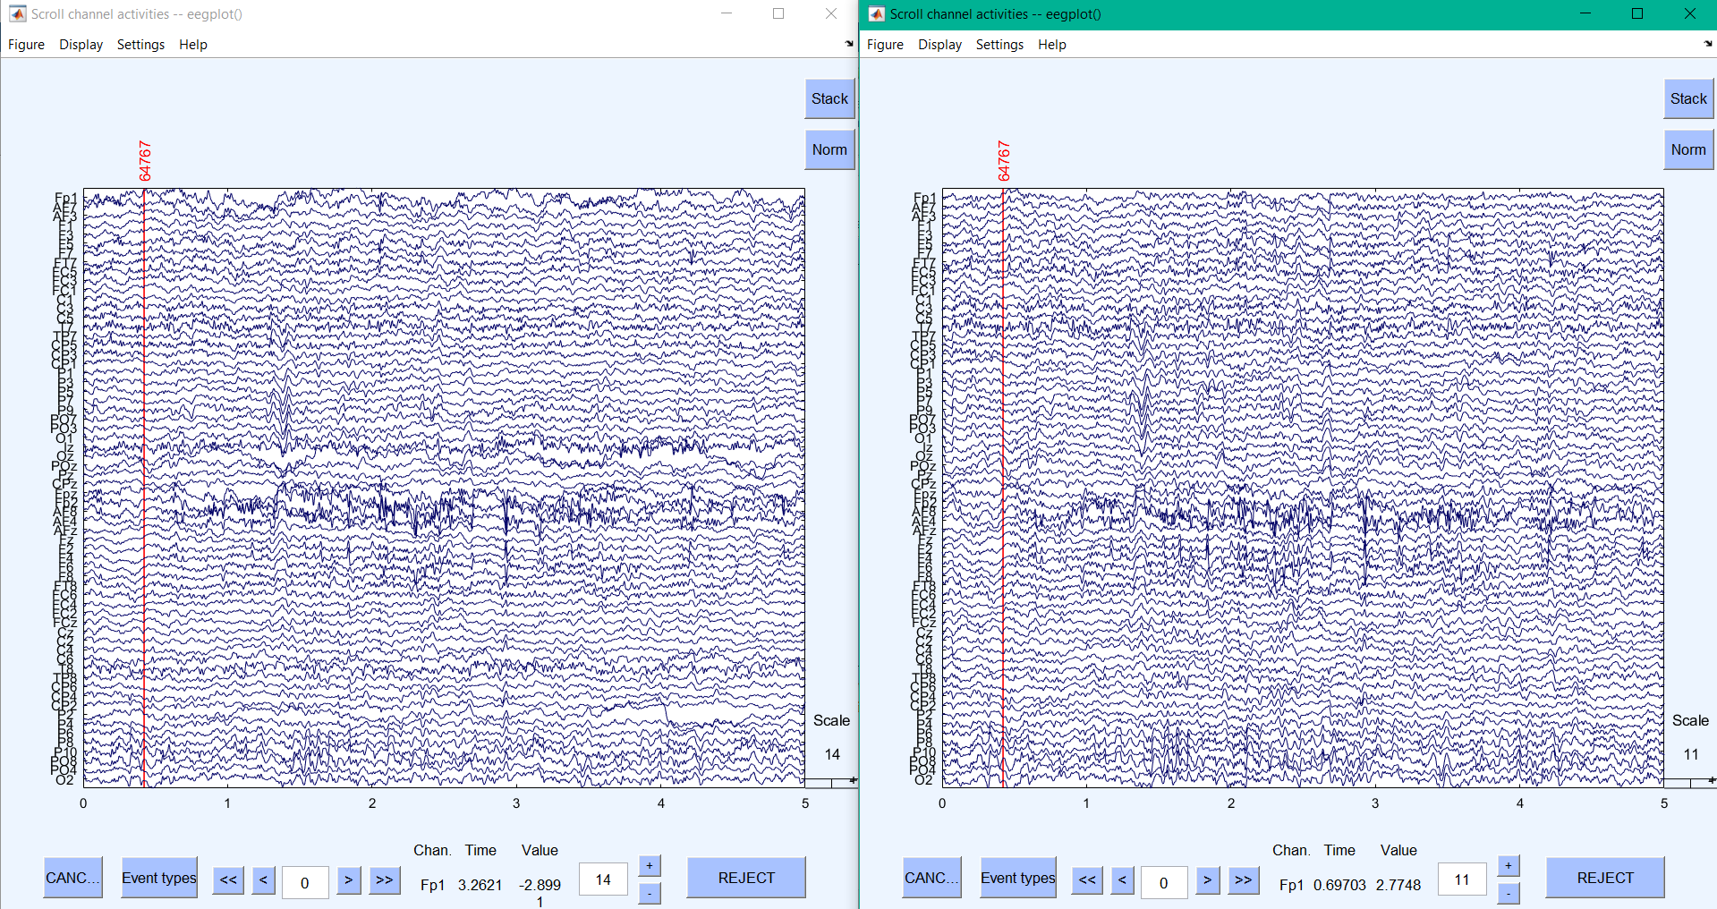

The before (left) and after (right) ICA removal-eyes open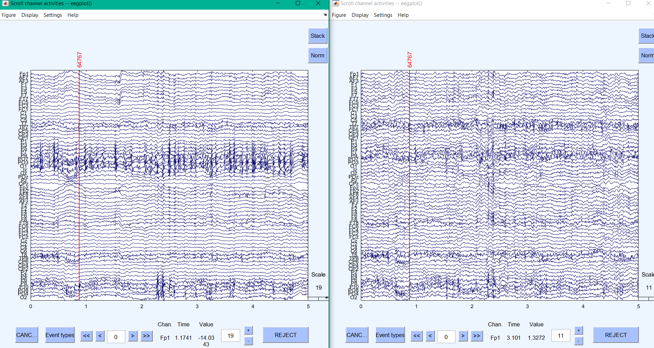

Data plot for 5 sec for closed eyes data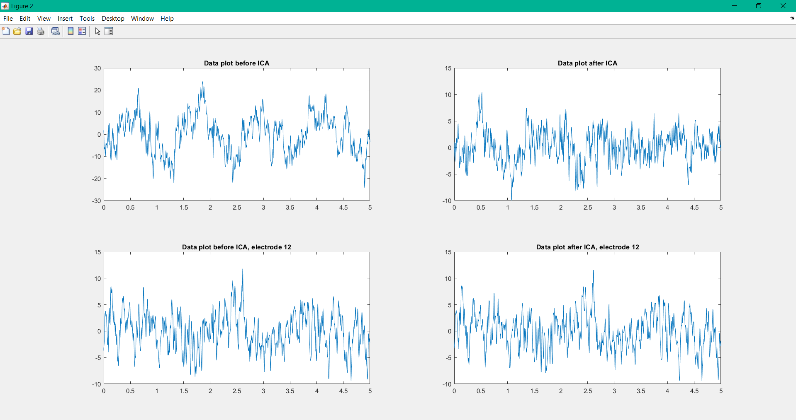

Data plot for 5 sec for open eyes data 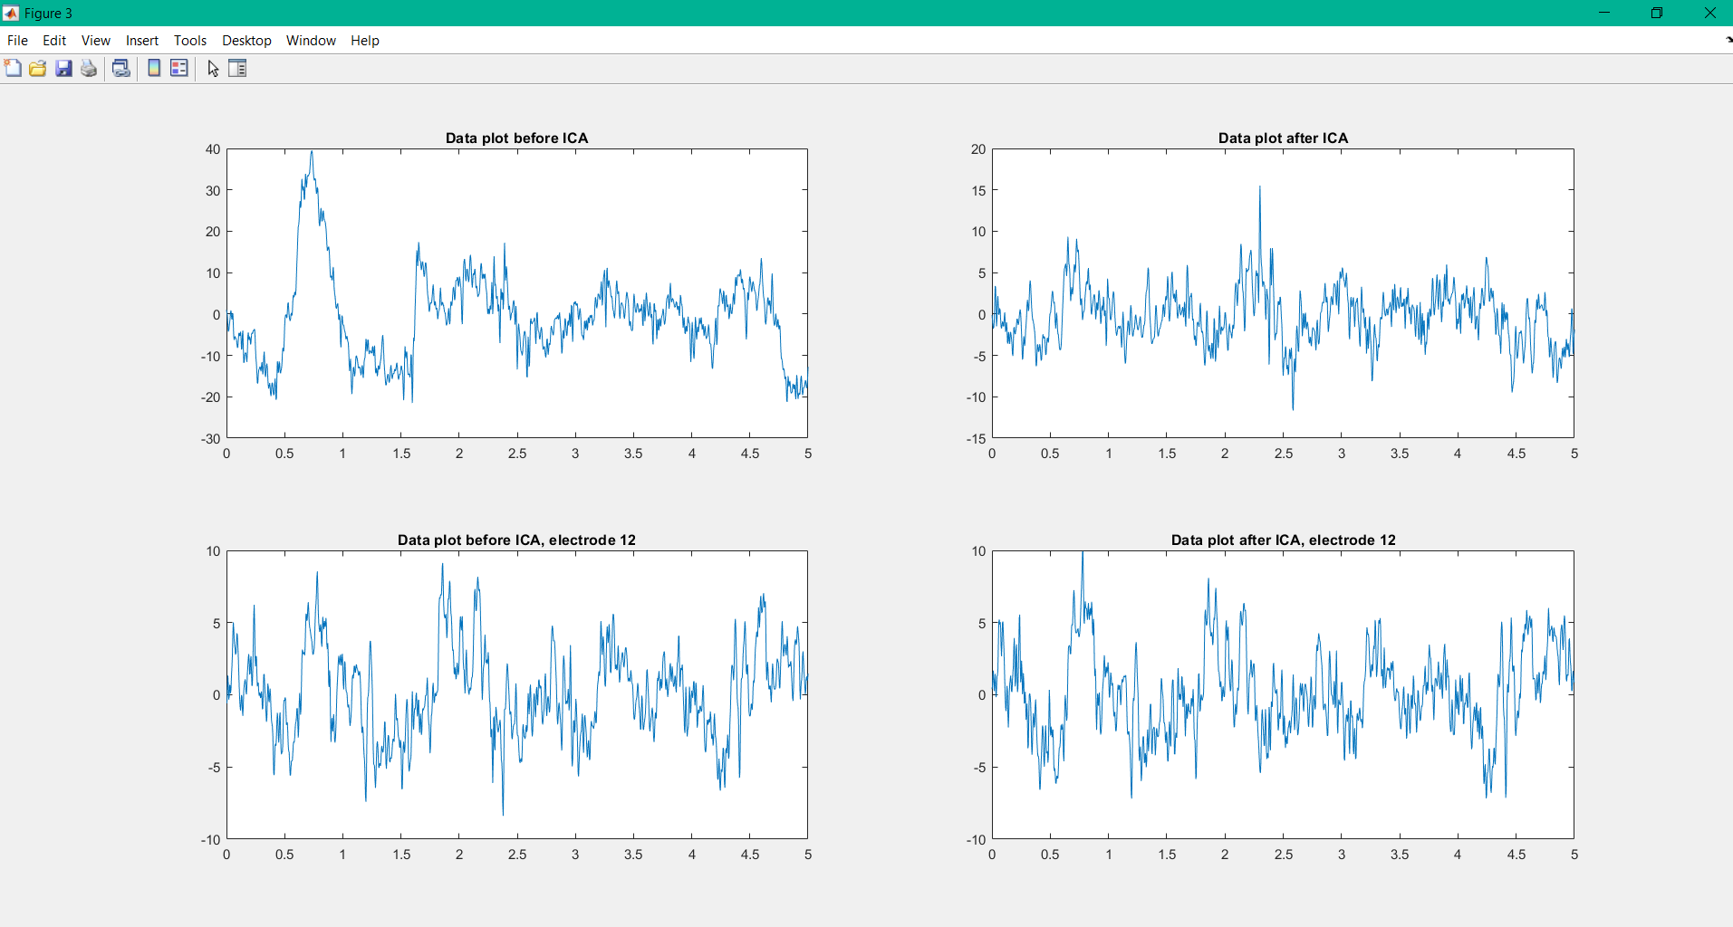

Amplitude/power distribution of brainwaves’ frequency of closed eyes data

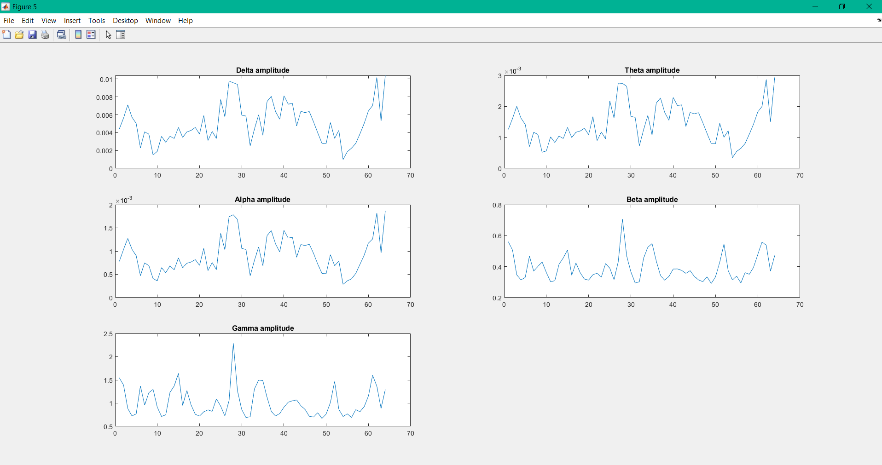

Amplitude/power distribution of brainwaves’ frequencies of open eyes data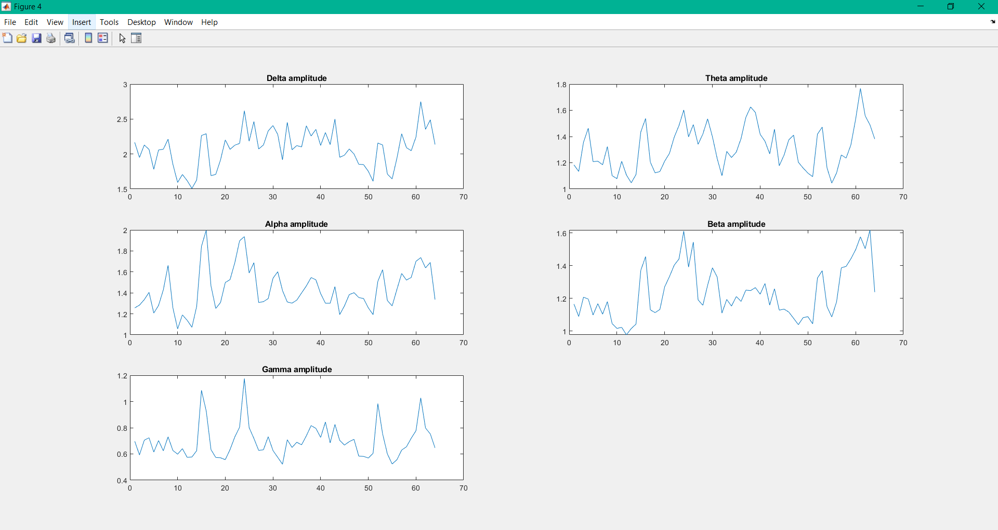

Close and open mean graph

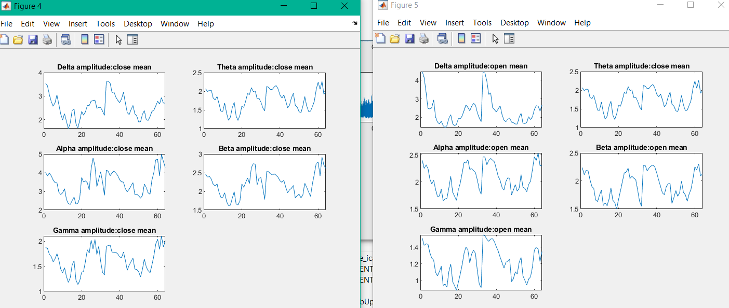

Topography of close and open mean

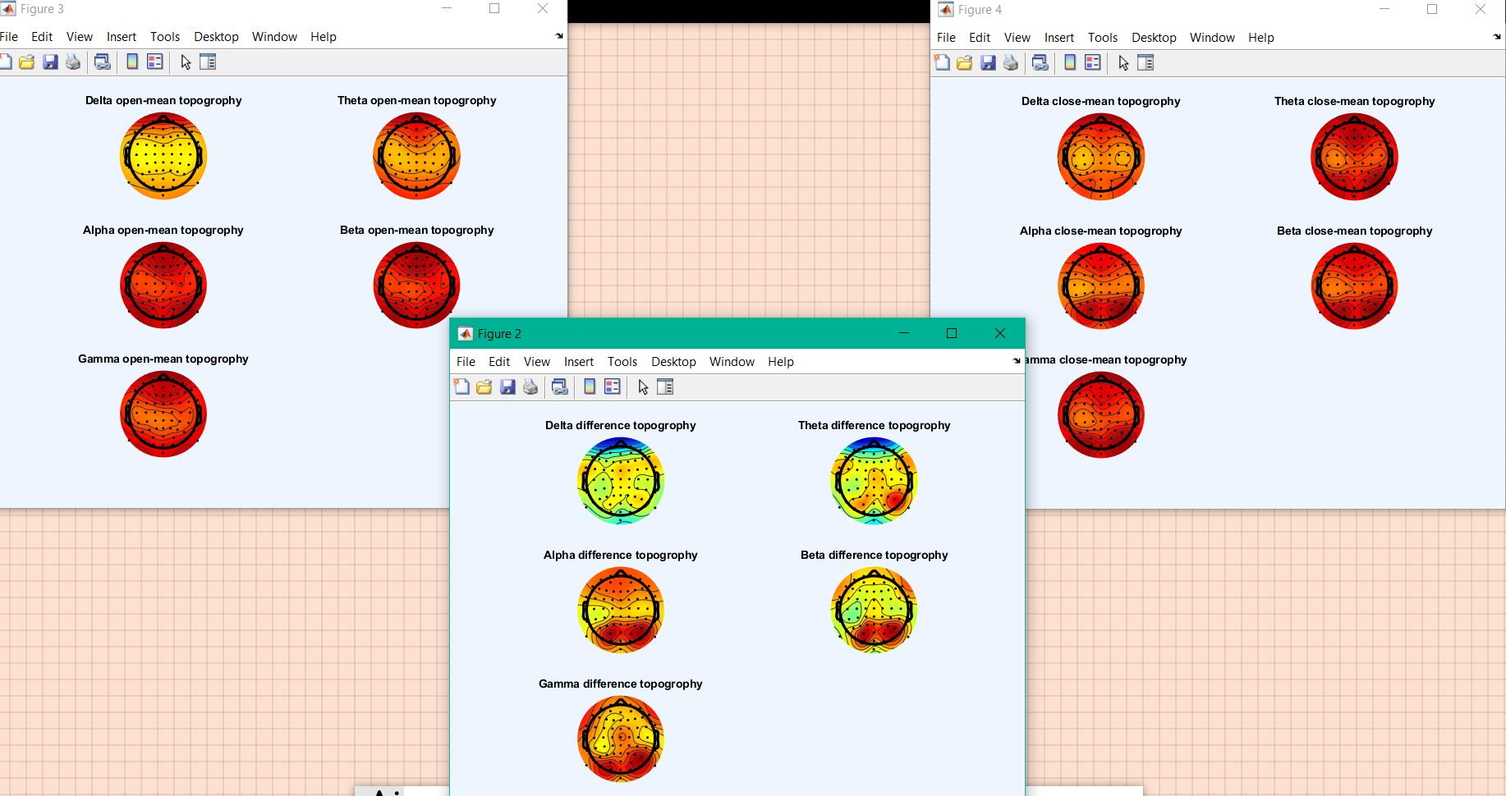

After playing with contrast

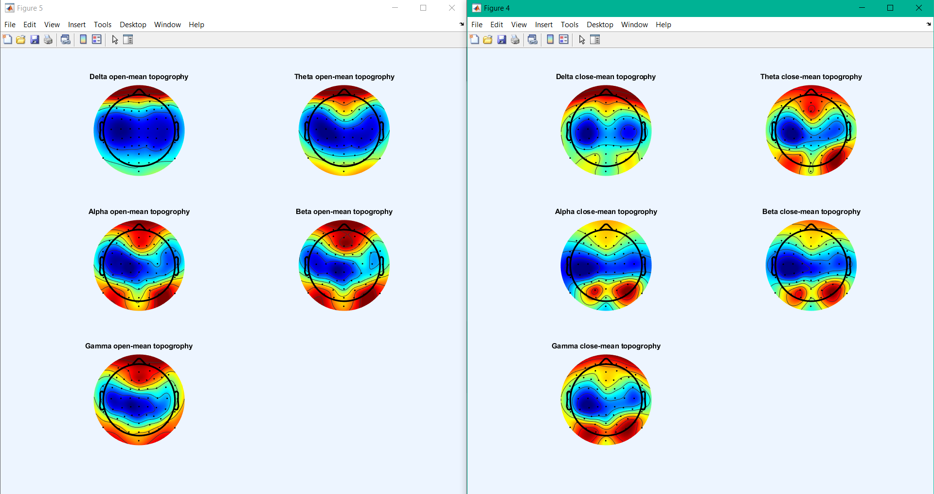

For example I see here that open mean leans mostly on darker colors (lower power value) while closed eyes mostly has warm colors (higher power value) which might justify the skin conductance increasing from closed eyes to open eyes.

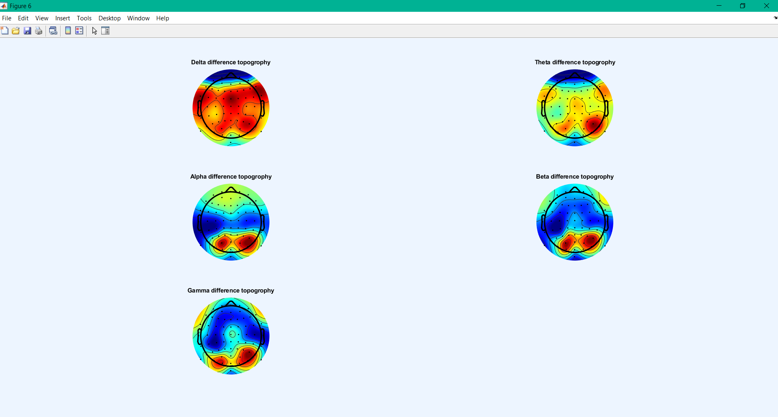

Topogrophy of closed eyes EEG

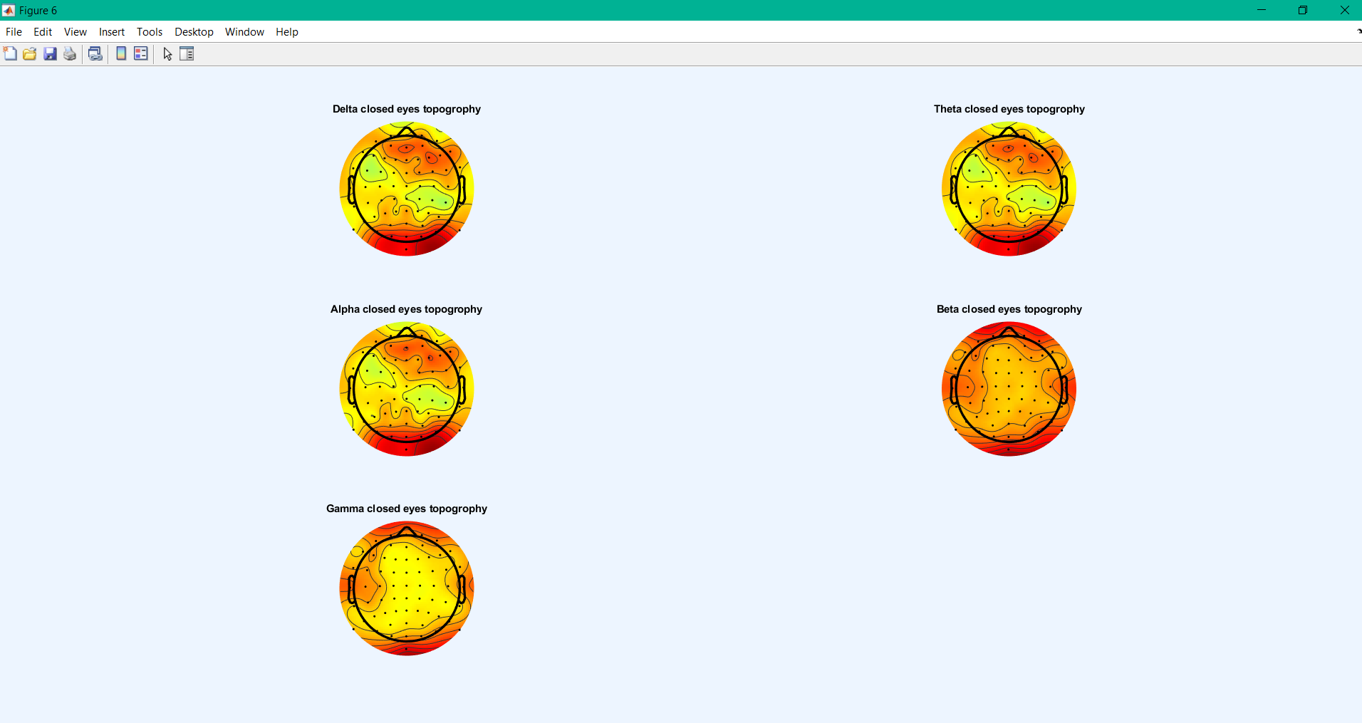

Different contrast of topography of closed eyes

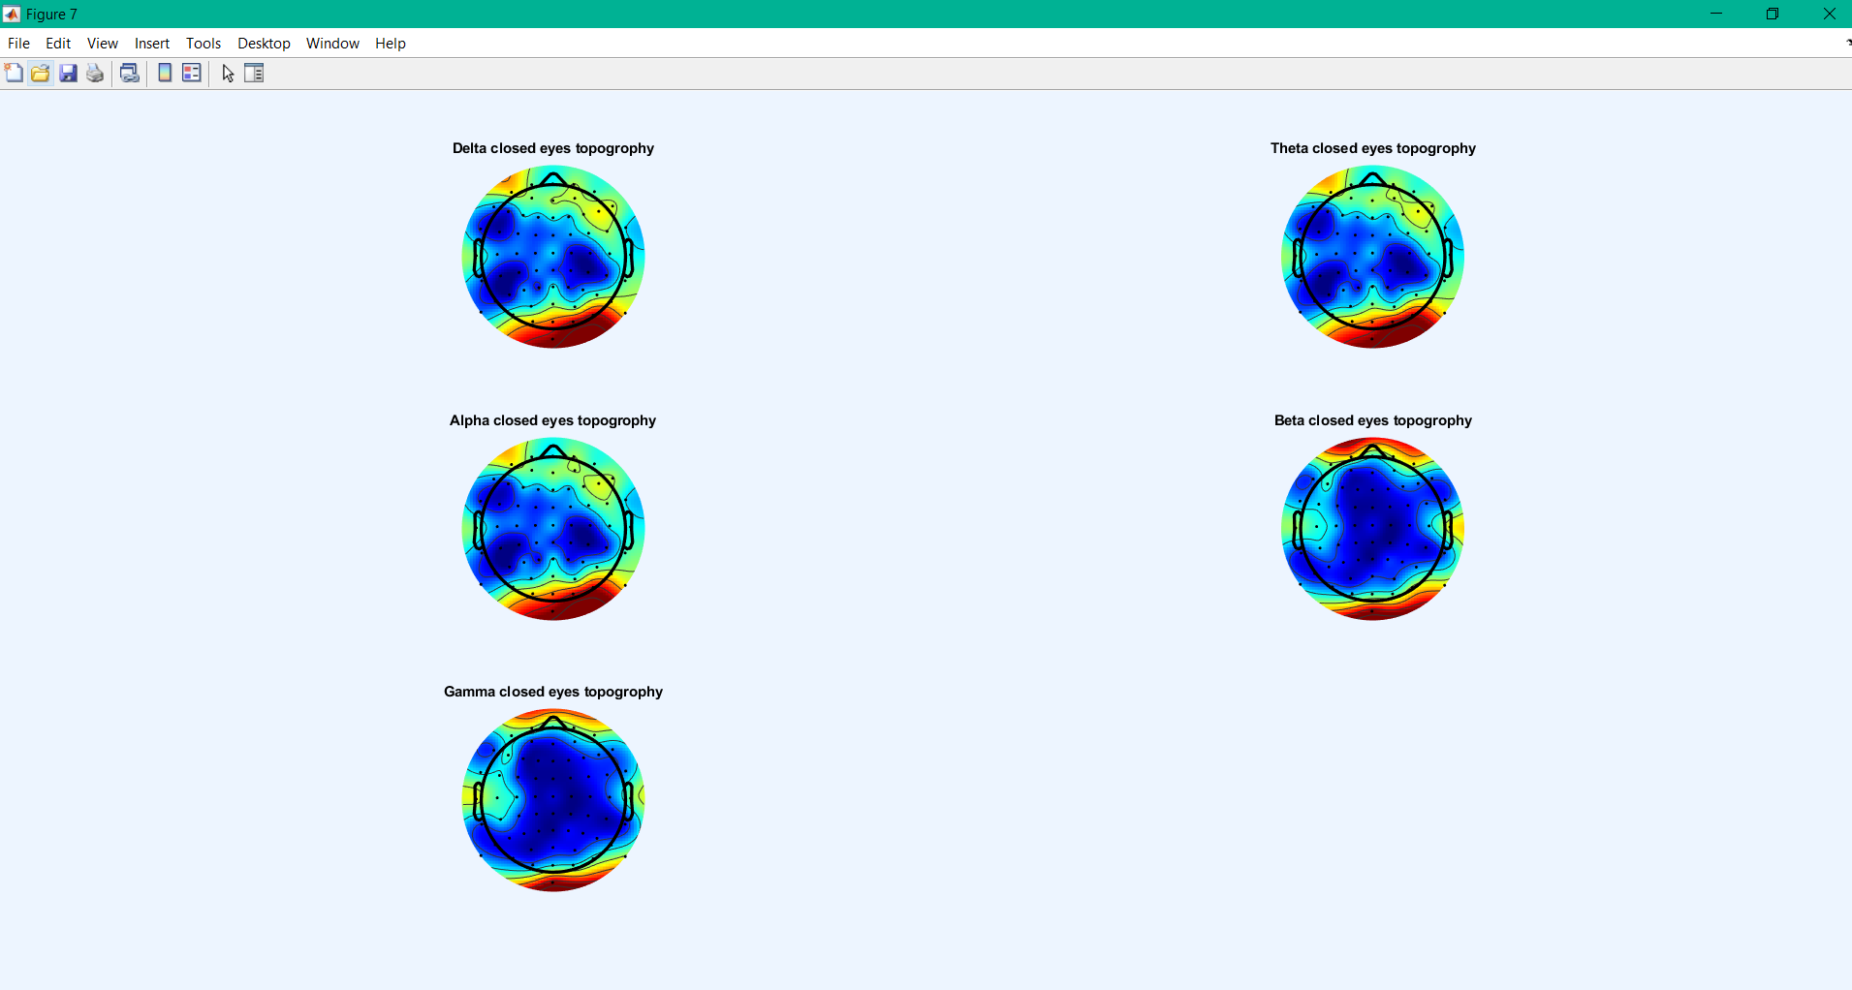

Topography of open eyes EEG data

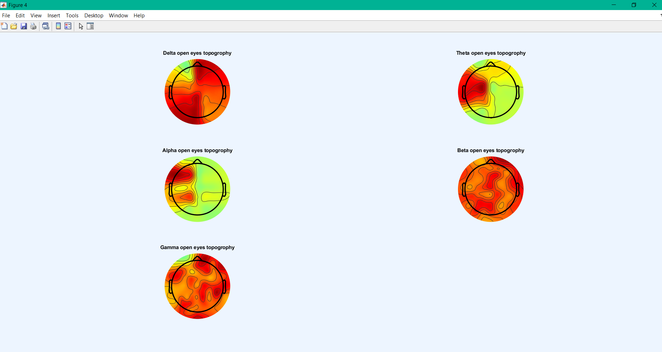

After contrast of power values of open eyes file:

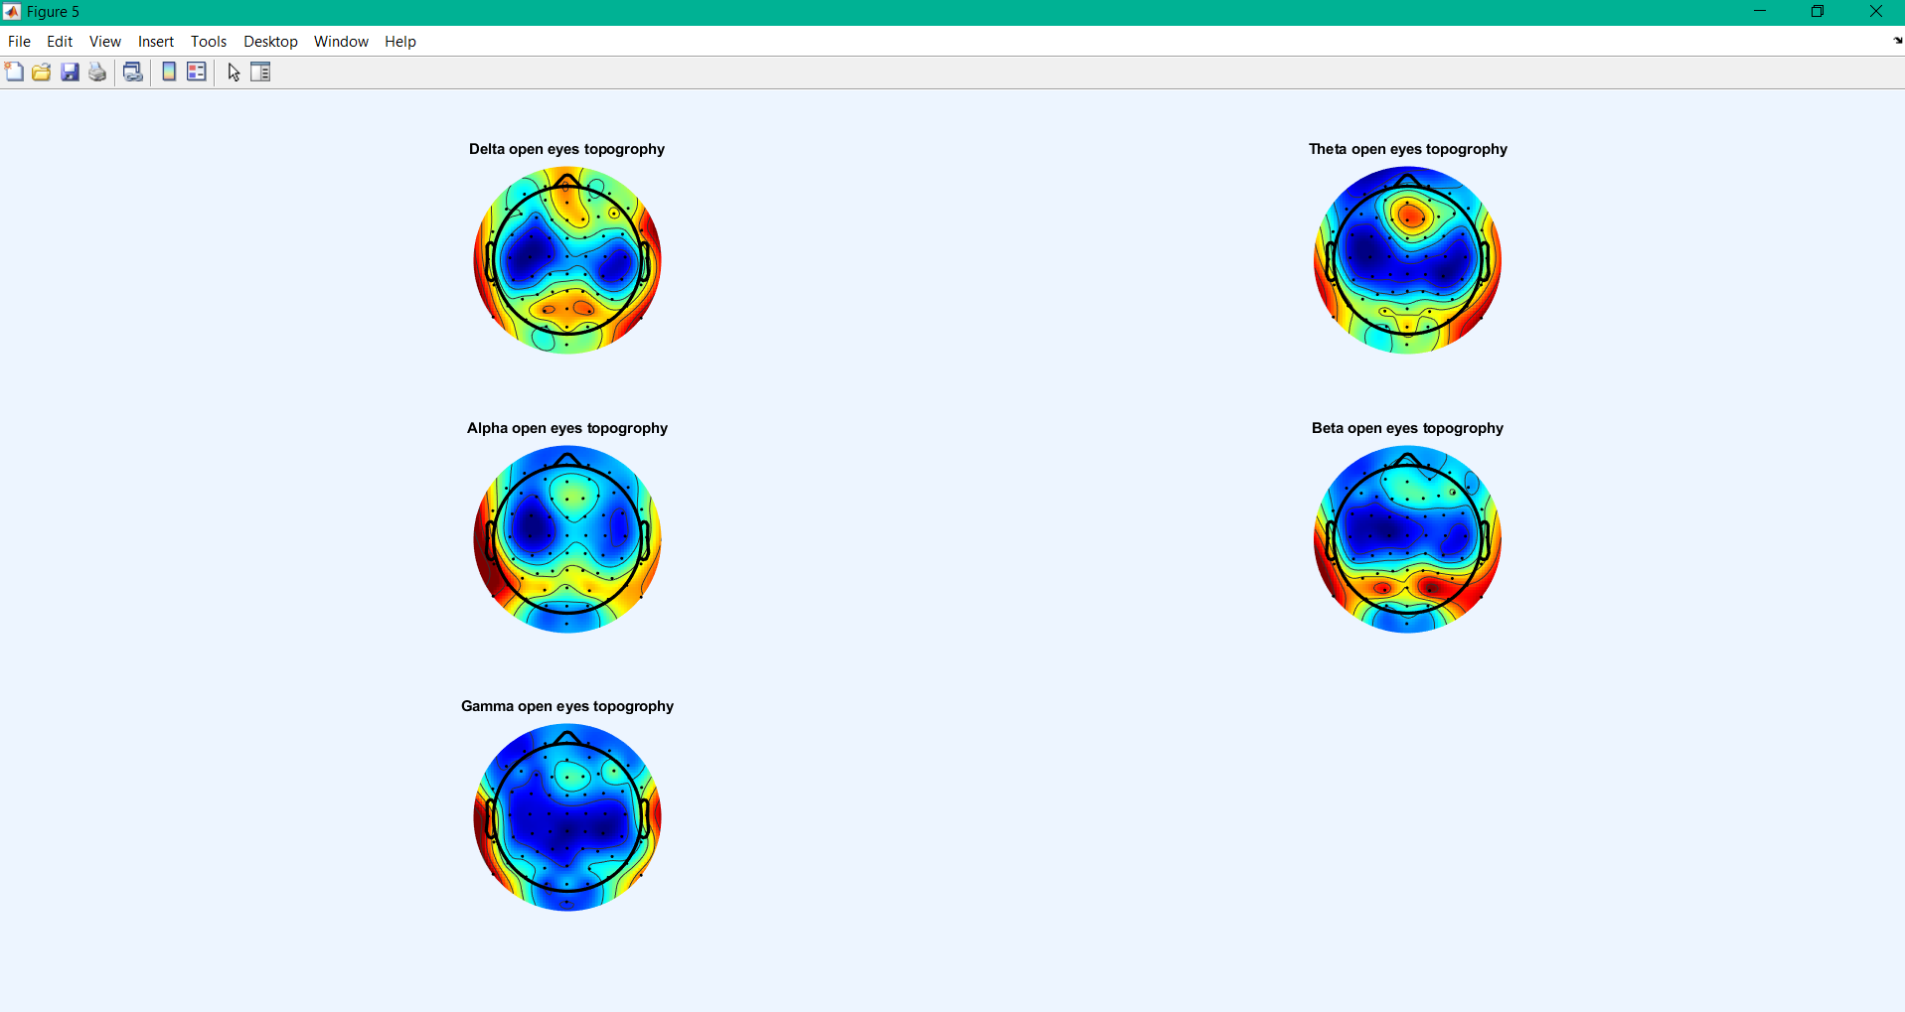

Difference of open-eyes and closed-eyes topographies

